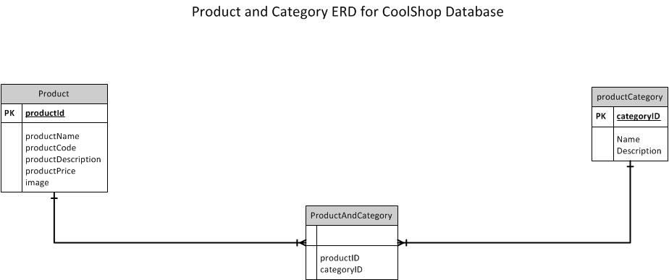

Note:

1. Any thought on the Product Price? Separe table
2. We can run an sql statement to insert data to ‘productCategory’ table but not ‘product’ table because an image has to be inserted using a PHP form

|  |  |  |  |  |
| --- | --- | --- | --- | --- |
| Product Table | | | | |
| **productID** | **productName** | **productDescription** | **productPrice** | **Image** |
| 1 | Jean | Denim Jeans | $25.00 | 1.jpg |
| 2 | Jacket | Nylon | $30.00 | 2.jpg |
| 3 | Trousers | Cropped | $50.00 | 74KZG.jpg |
| 4 | Cups | Drinking cup | $5.00 | images (1).jpg |
| 5 | Skinny Jeans | Denim Jeans | $69.00 | 36329021.jpg |

|  |  |  |
| --- | --- | --- |
| Product Category Table | | |
| **categoryID** | **categoryName** | **categoryDescription** |
| 1 | Denim Jeans | High Quality Jeans |
| 2 | Kitchen Utencils | All utensils for the kitchen and household |
| 3 | Homeware | Indoors and outdoors tools |
| 4 | Suit | Working suits, Ties, sleeves |
| 5 | Jacket | Winter Jackets |

|  |  |
| --- | --- |
| ProductAndCategory Table | |
| **productID** | **categoryID** |
| 1 | 1 |
| 2 | 5 |
| 3 | 4 |
| 4 | 2 |
| 5 | 1 |
|  |  |
|  |  |

**SQL Statement**

create database coolshop;

use coolshop;

create table category (

category_id char(4) auto_increment primary key,

category_name varchar(20) not null,

category_desc varchar(100) not null,

) engine = innodb;

create table product (

productID char(10) auto_increment primary key,

product_name varchar(10) not null,

productDescription(30) not null,

productPrice(30) not null,

product_image blob,

category_id int,

) engine = innodb;

insert into category values (“Denim Jeans”, “High Quality Jeans”);

insert into category values (“Kitchen Utencils”, “All utensils for the kitchen and household”);

insert into category values (“Homeware “Indoors and outdoors tools”);

insert into category values (“Suit “Working suits, Ties, sleeves”);

insert into category values (“Jacket “Winter Jackets”);